*PlayStation 2 Controller- Arduino Interface*

Step I: Hardware

Have a look at [*this*](http://www.billporter.info/2010/06/05/playstation-2-controller-arduino-library-v1-0/)link for a detailed description of the connection.



PlayStation2 Controller Pinout

1 - DATA ( MISO )

2 - CMD ( MOSI )

4 - GND

5 - VCC ( 3.3V )

6 - SS ( Slave Select )

7 - SCK ( Synchronous Clock )

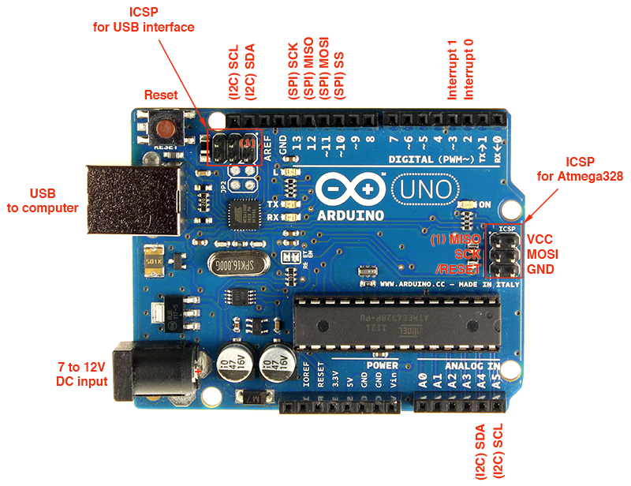

Arduino Uno As an Example Board

13 - SCK

12 - MISO ( DATA )

11 - MOSI ( CMD )

10 - SS

Connection => PS2 Arduino

1 <----> 12 DATA <----> DATA

2 <----> 11 CMD <----> CMD

6 <----> 10 SS <----> SS

7 <----> 13 SCK <----> SCK

This interface is known as *Serial Peripheral Interface* . Google the same for in-depth description.

Step II: Program

Download and install PS2X_lib from [*this*](http://www.billporter.info/2010/06/05/playstation-2-controller-arduino-library-v1-0/) website. Upload PS2X_Example sketch through Arduino IDE and adjust the respective parameters for the target board. Use *Serial Monitor* to verify proper connection. In case of any malfunctioning refer to this[*troubleshooting guide*](http://www.billporter.info/2011/03/27/arduino-playstation-2-controller-library-troubleshooting-guide/).